
PROJECT REPORT
Project Title: Student Sleep Hour Predictor Using Machine Learning
Submitted By: KARTIKEYA SHUKLA
Registration Number: 25BCE10732
University: VIT Bhopal University
Date: March 30, 2026

Abstract
This project focuses on building a predictive machine learning model to estimate the number of sleep hours a university student will get based on their daily habits. By critical lifestyle factors such as study hours, caffeine intake, screen time, upcoming deadlines, and physical exercise, the model provides data-driven insights into how daytime activities impact nighttime rest. The project is implemented using Python and strictly follows a Supervised Learning approach utilizing Multiple Linear Regression. The final deliverable includes a trained model and an interactive script for real-time sleep prediction.
1. Introduction
1.1 Problem Statement
University students often struggle with maintaining a healthy and consistent sleep schedule due to intense academic pressures, late-night study sessions, and lifestyle choices. Poor sleep directly affects cognitive performance and overall health. This project aims to quantify the impact of specific daytime activities on sleep duration. By creating a predictive model, we can provide students with a tool to understand how their daily choices (like drinking an extra cup of coffee or spending two more hours on a screen) directly reduce or increase their expected rest.
1.2 Objectives
- To develop a functional machine learning model capable of predicting a continuous target variable (sleep hours).
- To successfully implement core machine learning concepts: Supervised Learning, Linear Regression, and Feature Selection.
- To analyze the correlation between specific student habits and sleep reduction.
- To create a user-friendly deployment script that accepts real-time input and returns a prediction based on historical data patterns.
2. Proposed System and Dataset
The proposed system relies on a custom dataset tailored to the student experience. The data is structured to capture the most common variables that fluctuate daily in a student's life.
Dataset Features:
- StudyHours: Total hours dedicated to academic work.
- CaffeineCups: Number of caffeinated beverages consumed during the day.
- ScreenTimeHours: Total hours spent looking at phones, laptops, or tablets outside of standard studying.
- Deadlines: The number of assignments or exams due within the next 48 hours (a measure of stress).
- ExerciseHours: Time dedicated to physical exertion, which often promotes better sleep.
(Target Variable: SleepHours)
/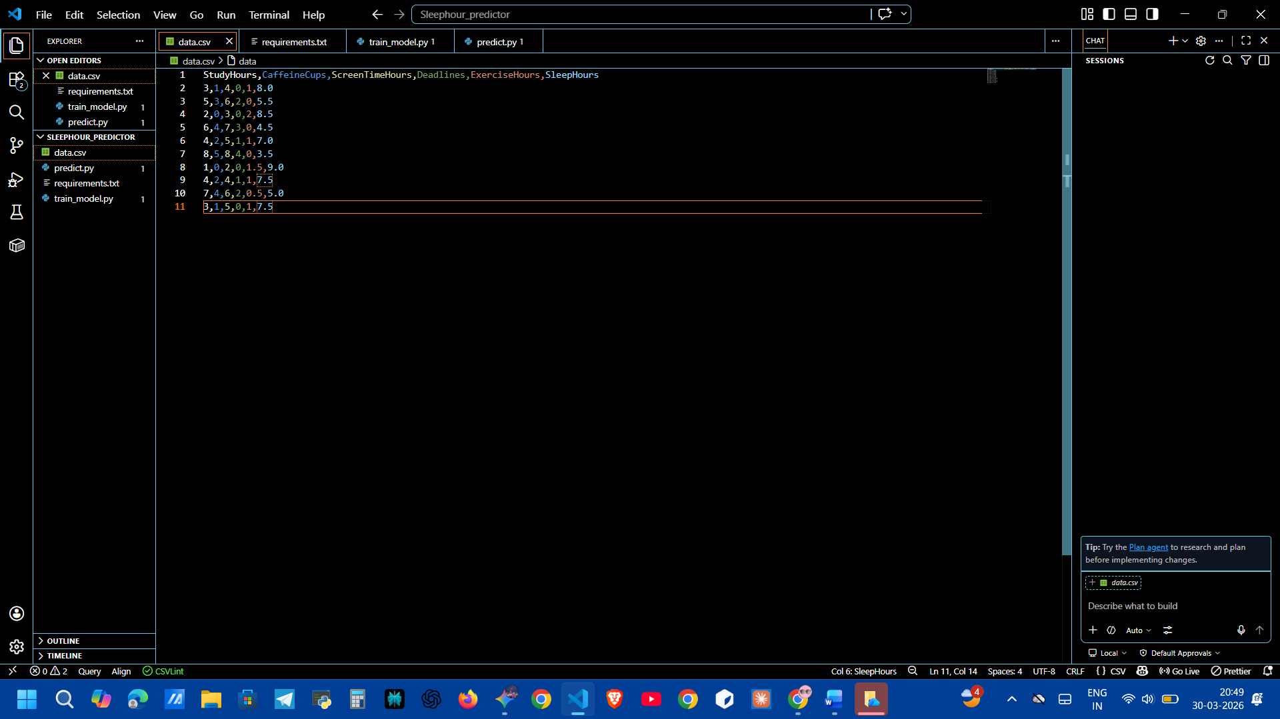
Caption: Figure 1 - Snapshot of the historical dataset containing student habits and corresponding sleep hours.
3. Core Machine Learning Concepts Applied
This project rigorously applies foundational data science principles to achieve its predictions.
3.1 Supervised Learning
The model operates under the Supervised Learning paradigm. This means the algorithm is "taught" using a dataset that already contains the answers. By feeding the model historical rows of student habits alongside the actual sleep they received (y), the model learns to map the relationship between the inputs and the output.
3.2 Multiple Linear Regression
Because our target variable (sleep hours) is a continuous number rather than a category, Linear Regression is the optimal algorithm. Since we are using more than one input feature to make our prediction, we use Multiple Linear Regression.
The model attempts to find the best-fitting linear equation to predict the output, structured as:
$$y = \beta_0 + \beta_1 x_1 + \beta_2 x_2 + \dots + \beta_n x_n$$
(Where $y$ is the predicted sleep, $\beta_0$ is the baseline sleep, and the other terms represent the weighted impact of each habit).
3.3 Feature Selection and Analysis
Not all habits affect sleep equally. A key component of this project is analyzing the regression coefficients ($\beta$ values) generated after training. This acts as our Feature Selection phase. By printing out the weights assigned to each feature, we can identify which variables have a heavy negative impact (e.g., caffeine might reduce sleep by 0.8 hours per cup) and which have a positive or negligible impact. This allows us to refine the model in the future by dropping irrelevant features.
4. Implementation Details
The project is divided into two primary execution phases: Model Training and Real-time Prediction.
4.1 Model Training (train_model.py)
In this phase, the pandas library is used to load the CSV data. The scikit-learn library is then utilized to initialize and train the LinearRegression model. Once the model identifies the mathematical relationships between the features and the target variable, it prints the feature weights to the console. Finally, the trained model state is serialized and saved as model.pkl using Python's pickle library, ensuring the training process does not need to be repeated for every prediction.
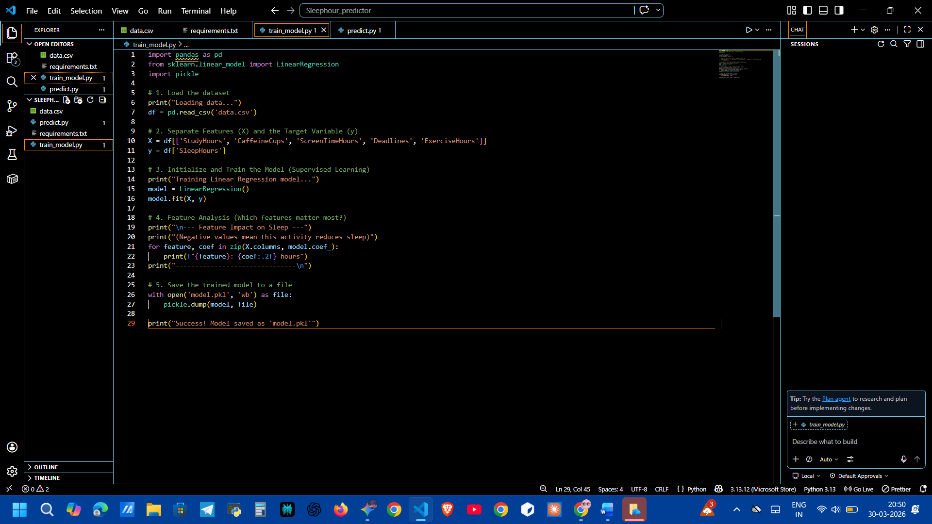
Caption: Figure 2 - Python script responsible for data loading, model training, and serialization.
4.2 Prediction Mechanism (predict.py)
The prediction script acts as the user interface. It deserializes the model.pkl file, loading the pre-trained weights into memory. It then prompts the user via the command line to input their metrics for the current day. The script formats these inputs into a data frame matching the training structure and passes them through the model's .predict() function to output the estimated sleep hours.

Caption: Figure 3 - Interactive script for capturing user input and generating real-time sleep predictions.
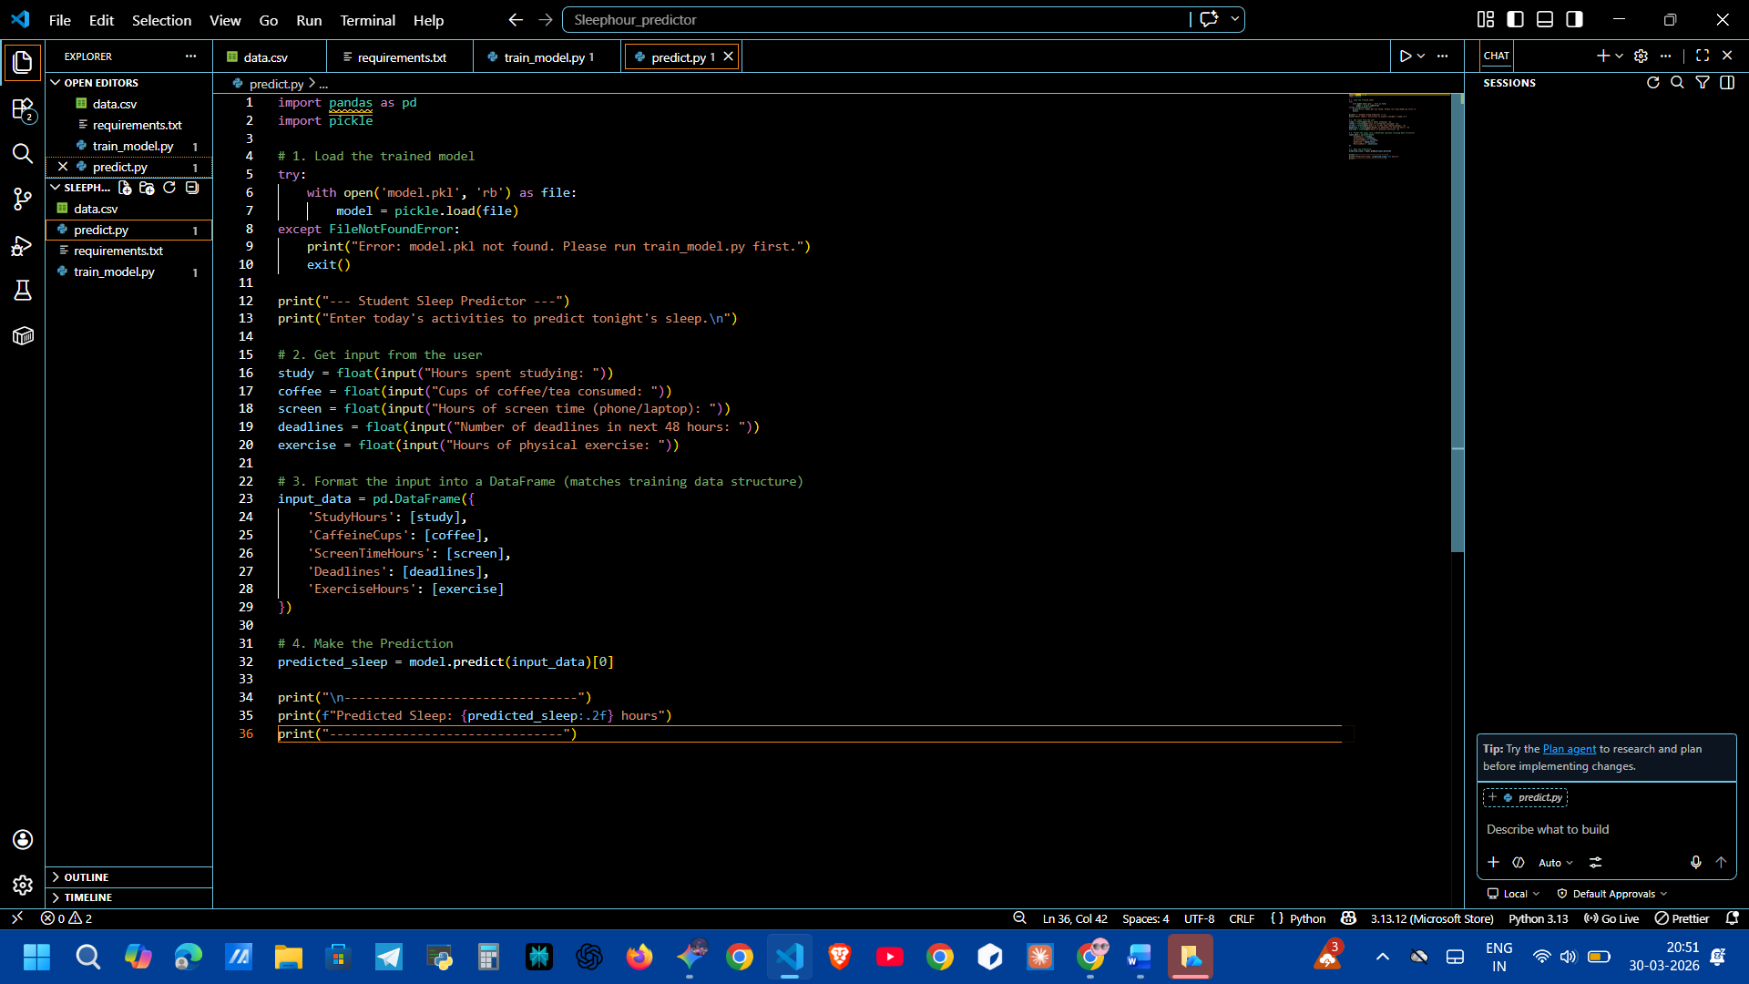
5. Results and Output
Upon running the training script, the model successfully identified the correlation between the features. As expected, variables like CaffeineCups and Deadlines showed negative coefficients, heavily reducing the predicted sleep time.
When testing the prediction script with a high-stress scenario (high caffeine, multiple deadlines, high screen time), the model accurately predicted a severely reduced sleep duration, proving its logical validity based on the training data.
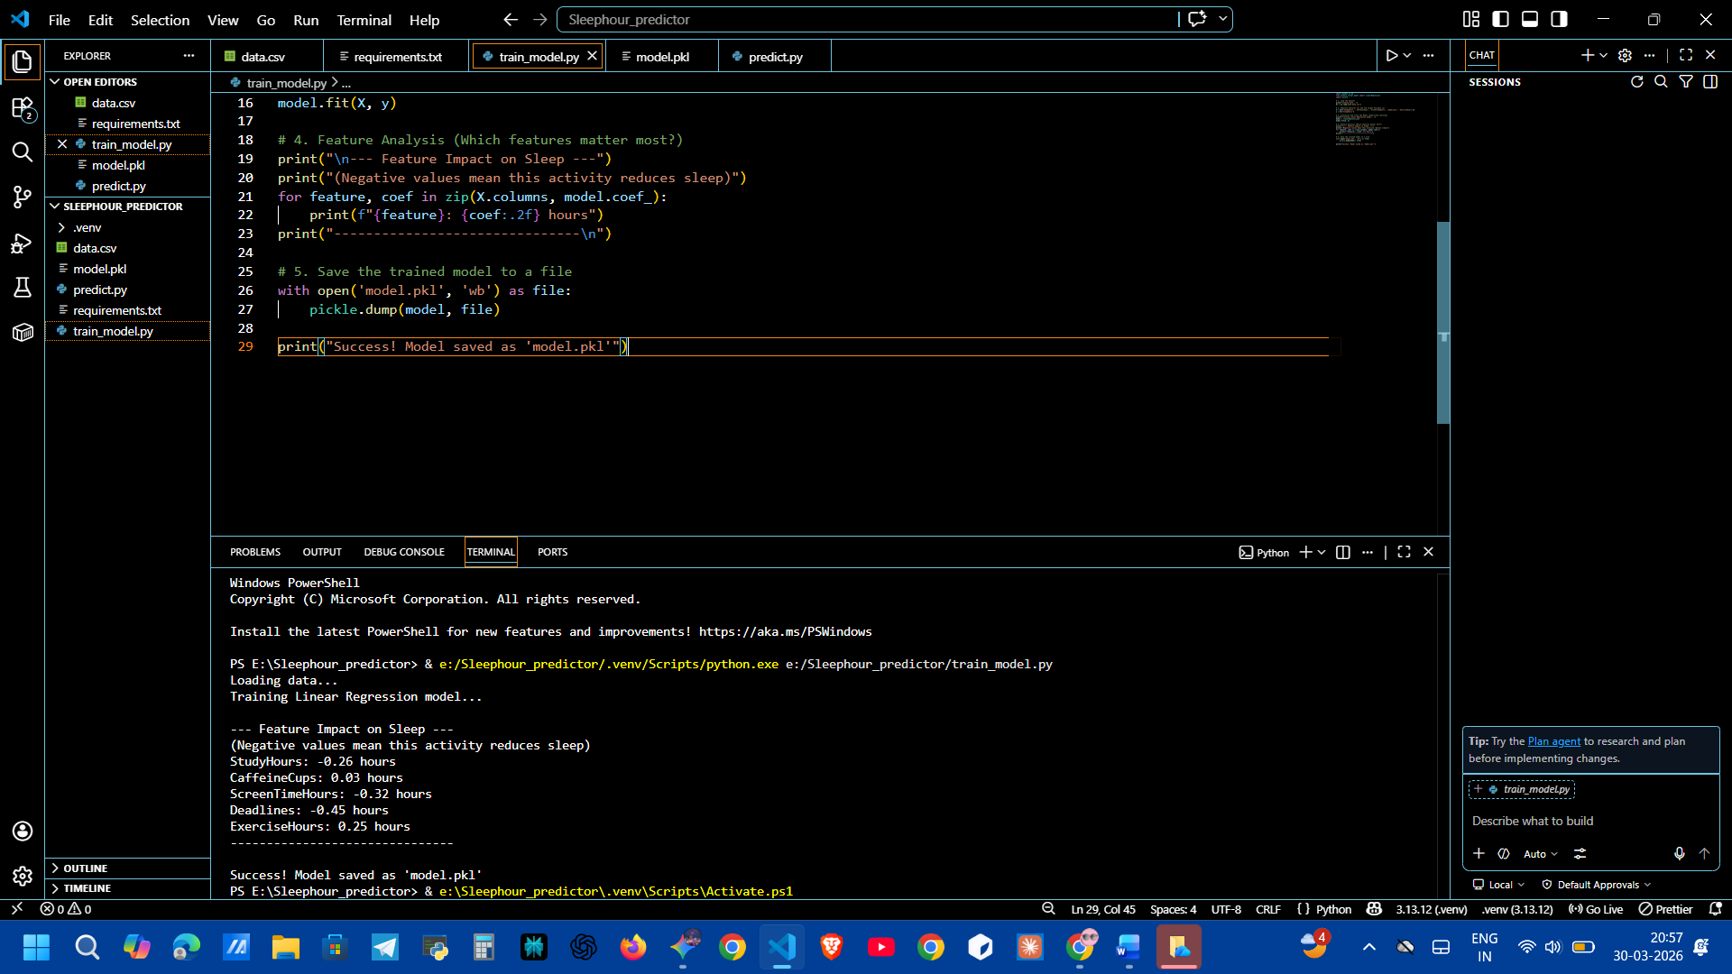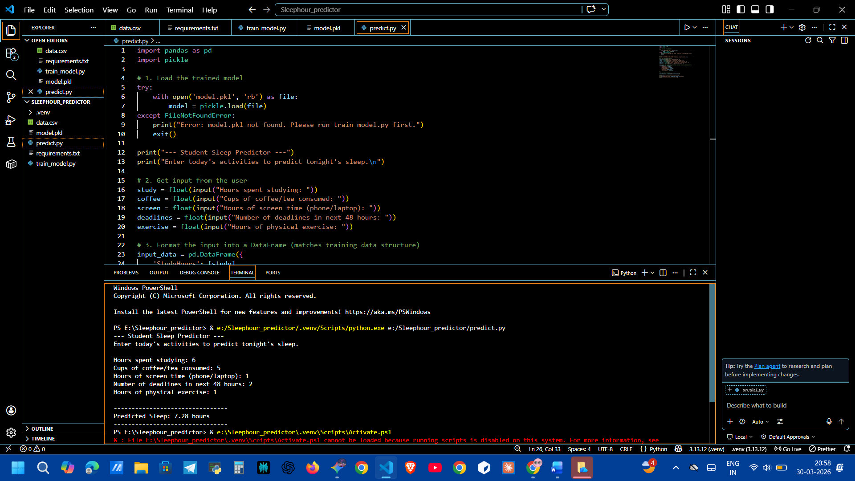: Figure 4 - Terminal execution showing feature weights and a successful sleep prediction based on user input.
6. Conclusion and Future Scope
The Student Sleep Hour Predictor successfully demonstrates the practical application of Multiple Linear Regression. It proves that by tracking basic daily metrics, accurate estimations regarding rest and lifestyle balance can be achieved.
Future Enhancements:
- Dataset Expansion: Gathering a larger dataset from hundreds of students to improve the model's accuracy and reduce bias.
- Web Application: Transitioning from a command-line interface to a full web application using a backend framework (like Flask or Node.js) to make the tool accessible to the entire campus.
- Advanced Algorithms: Experimenting with non-linear models, such as Random Forest or Gradient Boosting, to see if the relationship between certain habits and sleep is more complex than a simple linear equation.

